- What is the scale factor of a drawing if the scale is 1 inch = 6 feet?

  - −1−
72

  - −1
6

  - 6

  - 72

- Two angle measures in a parallelogram are labeled. Which term best describes the angles
65°

115
- complementary
- acute
- obtuse
- supplementary

- Which of the following is a possible cross section of the figure below?

- hexagon
- square
- trapezoid
- triangle

4. What type of angle is shown below?
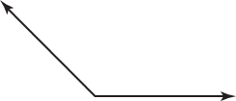
- acute

- right

- obtuse

- straight

- The angle measures of a triangle are 28°, 70°, and 82°. Which of the following
best classifies the triangle by its angle measures?

  - acute

  - obtuse

  - right

  - scalene

- Which of the following describes the shape resulting from the cross section below?

- rectangle

- square

- triangle

- parallelogram

- Terrance is making a scale model of a car that is 16 feet long. He is using the scale 1 inch = 2.5 feet. How long is Terrance’s model?

  - 5.8 in.

  - 6.4 in.

  - 28 in.

  - 40 in.

- Which of the following describes the shape resulting from the cross section below?

A. circle

B. oval

C. rectangle

D. line

- Which of the following best classifies the triangle below by its angles and sides?

- acute, isosceles
- acute, equilateral
- right, scalene
- right, isosceles

10. What is the measure of x in the figure
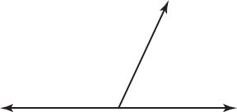

x 65
A. 25°
B. 65°
C. 115°
D. 125°
11. Which of the following shows a straight angle?
A. B. C. D.

